Green Charter Township
E-mail: supervisor@greentownship.org
21431 Northland Drive (PO Box 233) - Paris, Michigan 49338
PH: 231/796-6201
April 1, 2021

For the residents of Green Charter Township,

There is an election Tuesday May 4th. Everyone is coming to you wanting more money. You must decide what you are most concerned about and is it worth the cost.
Your Green Charter Township Board of Trustees (long title isn’t it) has heard several opinions about the condition of our local roads and how to fund their repair. Who is the majority and who is a vocal minority? A vote is the only way to know.
FACTS: The state, the county, the Road Commission, no one is going to fund local road repairs in the foreseeable future. IF we want more done than currently, WE are going to have to fund it.
Suggested Maintenance | Base Costs/Mile
Crack Seal | $ 4,500.00
Chip & Fog | $ 35,000.00
Overlay | $ 115,000.00
Wedge & Overlay or Mill & Fill | $ 125,000.00
Pulverize & Pave | $ 180,000.00
Reconstruct Base & Pave | $ 360,000.00
COST: What does it cost to fix a blacktop road? This chart comes with the annual report from the Road Commission. In addition, we have 32 miles of local gravel roads that need more help.
NEED: We receive a “Paser” report each year listing the worst black top roads in our township. It lists 24 projects in just the 2 most expensive categories. The worst 6 of these have a total price tag of $1 million dollars. The report lists a total of 55 projects in need of attention just in Green Charter Township.
PROPOSED SOLUTION: The ballot initiative calls for 2 mills for 5 years. This, plus continuing to pull some from the general fund will raise $1 million over the 5 years. We won’t get caught up, but we will have good handle on the worst problems. This money would be spent ONLY in our township and administered by the Township Board.
For you it means 2 mills or 2 dollars per $1000 of assessed value. If your house would sell right now at $100,000 then the increase would be $100 dollars.
In the end the decision is yours. Your Board of Trustees will administrate your road millage to improve the roads. OR we will continue putting what we can from the general fund (approx. $50k - $75k per year) towards the issue.
The decision is yours, but PLEASE stop in May 4th. Vote, and make your voice heard.

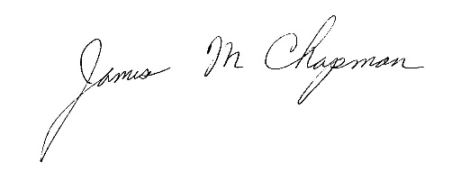
Respectfully,

James M Chapman, Supervisor
Green Charter Township

